Composition: Electronic Media II
Spring 2011
Assignment 1

1. Assignment 1 will be presented in class on Feb. 7, 2011.

2. The purpose of this assignment is to learn through documentation and experimentation the different types of signal processing
sound transformations available in SoundHack.

3. SoundHack is freeware and can be downloaded for Mac at: http://www.soundhack.com/freeware.php. The latest version is 0.896
Universal Binary, as shown below.

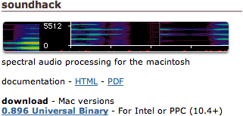

4. Documentation can be opened in html or downloaded as a PDF file.

5. SoundHack works by opening an aiff soundfile, then selecting the Hack menu, whose items are shown below:
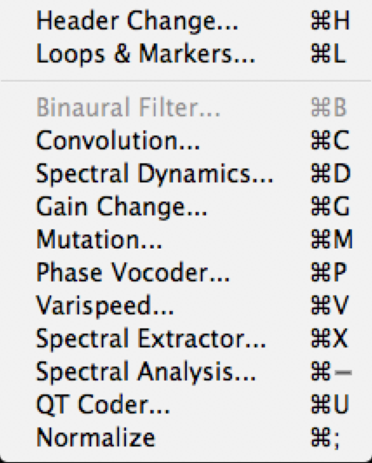

6. Each student in class will give a 20-30 minute on one of the processes shown below:
a. Convolution: Yunsoo.
b. Mutation: Matt
c. Phase Vocoder: Stephanie
d. Varispeed with drawing function: Tyler
e. Spectral Extractor: Brian (who has the option of presenting one of the plug-ins as discussed in class).

7. Each student will prepare 16 soundfiles with the following attributes:

Soundfile | High | Low | Short | Long | Pitched | Unpitched | Monophonic | Polyphonic
1 | • |  | • |  | • |  | •
2 | • |  | • |  | • |  |  | •
3 | • |  | • |  |  | • | •
4 | • |  | • |  |  | • |  | •
5 | • |  |  | • | • |  | •
6 | • |  |  | • | • |  |  | •
7 | • |  |  | • |  | • | •
8 | • |  |  | • |  | • |  | •
9 |  | • | • |  | • |  | •
10 |  | • | • |  | • |  |  | •
11 |  | • | • |  |  | • | •
12 |  | • | • |  |  | • |  | •
13 |  | • |  | • | • |  | •
14 |  | • |  | • | • |  |  | •
15 |  | • |  | • |  | • | •
16 |  | • |  | • |  | • |  | •

8. Each student will make a handout using the format of those in class. Screen snapshots are essential. The most important functions of each process should be listed in the handout and discussed in class.

9. Each function should be demonstrated with before and after examples using some of the soundfiles prepared in Step 7, above.

10. Below are some of the processes from the Hack menu:
a. Convolution
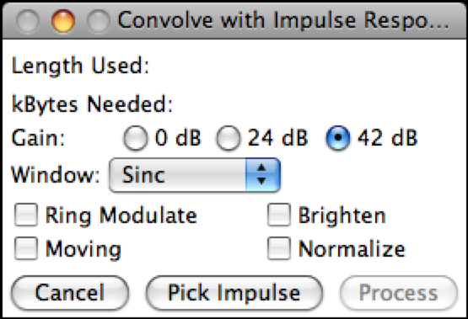

b. Mutation
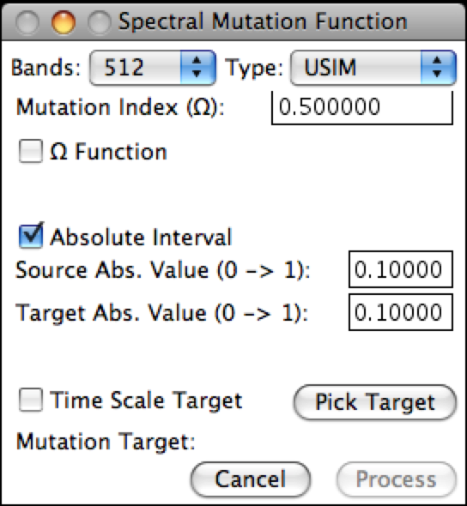

c. Phase Vocoder
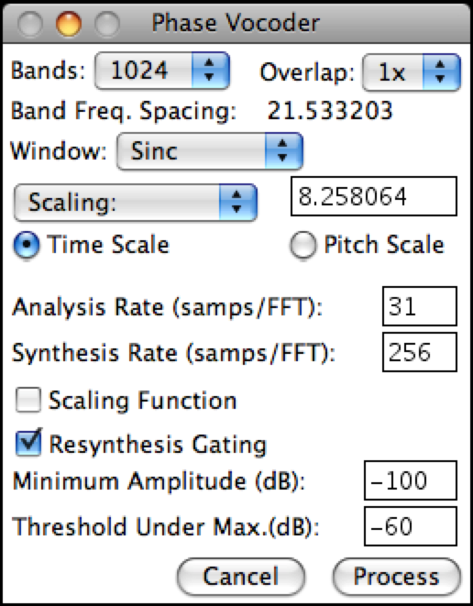

d. Varispeed
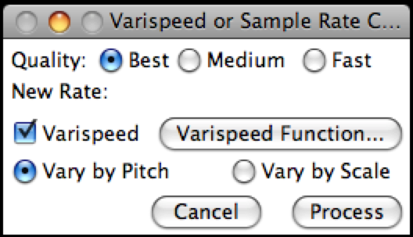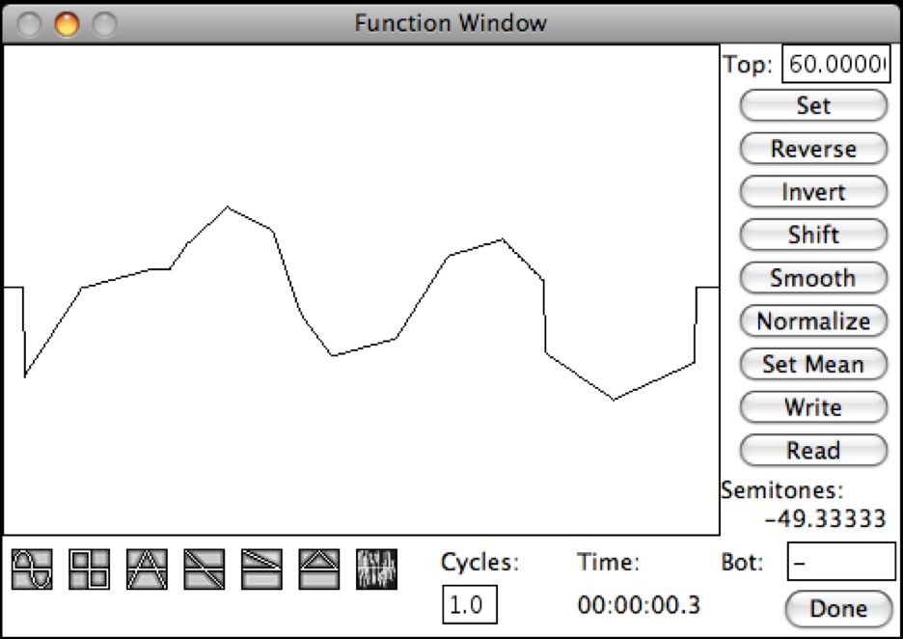

e. Spectral Extractor
